Assignment -6
Responsible AI
NAME : J.SANJANA
ROLLNO : 2503A52379
BATCH : 13
Task Description-1 : (Privacy &amp; Security in File Handling)
Task: Use an AI tool to generate a Python script that stores user data (name, email, password) in a file.
Analyze: Check if the AI stores sensitive data in plain text or without encryption.
Expected Output:
Identified privacy risks. Revised version with encrypted password storage (e.g., hashing).
INPUT FOR TASK 1 - CODE 1:
"""Part 1: intentionally insecure file-handling example.
This version is for demonstrating the privacy risk only. Never use it for a real application because it writes the password in plain text.
"""
name = input("Enter your name: ")
email = input("Enter your email: ")
password = input("Enter your password: ")
with open("users.txt", "a", encoding="utf-8") as
file: file.write(f"Name: {name}, Email: {email}, Password:{password}\n")
print("User information saved to users.txt.")
OUTPUT FOR TASK 1 - CODE 1:
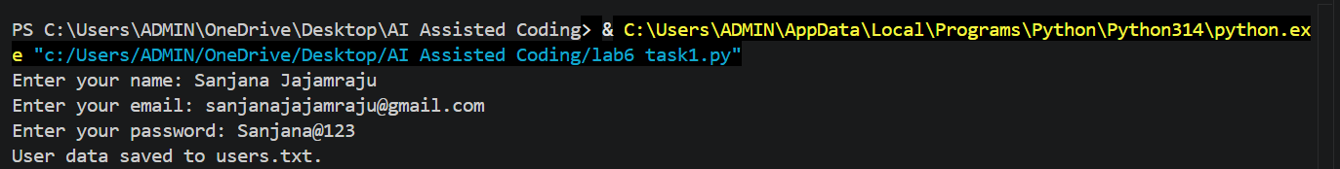
INPUT FOR TASK 1 - CODE - 2:
"""Part 3: safer password storage using only Python's standard library."""
import hashlib
import secrets from getpass
import getpass
name = input("Enter your name: ")
email = input("Enter your email: ")
password = getpass("Enter your password: ")
# A unique salt prevents identical passwords from producing identical hashes.
salt = secrets.token_bytes(16)
# PBKDF2 deliberately performs many hash calculations, making password
# guessing more difficult than using a single fast hash.
password_hash = hashlib.pbkdf2_hmac(
"sha256",
password.encode("utf-8"),
salt,
100_000,
)
# Security improvement: store the salt and hash, never the original password. with open("users_secure.txt", "a", encoding="utf-8") as file:
file.write
( f"Name: {name}, Email: {email}, "
f"Salt: {salt.hex()}, Password hash: {password_hash.hex()}\n"
)
print("User information saved securely to users_secure.txt.")
OUTPUT FOR TASK 1 - CODE 2:
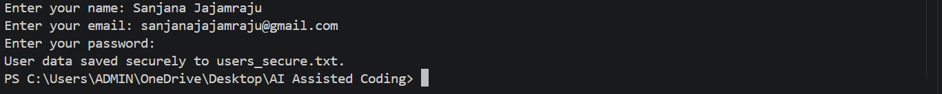
COMPARISION TABLE:
Original | REVISED
Writes the original password . | Does not write the original password.
Password is visible during typing | getpass` hides password input
Plain-text credential can be reused immediately | Salted PBKDF2 hash must be verified
Saves to `users.txt | Saves to `users_secure.txt

Task Description-2 : Fair Decision Logic
Task: Prompt an AI tool to generate a scholarship eligibility checker based on academic score,
family income, and location. Examine whether the logic unfairly favors or disadvantages any group.
Expected Output-2:
Code snippet with observations on fairness.
Brief explanation (3–4 sentences) suggesting improvements to ensure equitable decision- making.
INPUT FOR TASK 2 - CODE 1:
"""Fair Decision Logic demo: an intentionally biased scholarship checker.
This version is only for discussing fairness problems. The location bonus is not a suitable eligibility rule unless location is directly justified by the published scholarship requirements. """
def get_number(prompt: str, minimum: float, maximum: float | None = None) -> float:
value = float(input(prompt))
if value < minimum or (maximum is not None and value > maximum):
raise ValueError("Please enter a valid value.")
return value
academic_score = get_number("Academic score (0-100): ", 0, 100)
family_income = get_number("Family annual income: ", 0)
location = input("Location: ").strip() score = academic_score * 0.70
if family_income <= 30000:
score += 20
elif family_income <= 60000:
score += 10
# UNFAIR RULE: students from Urban areas receive extra points.
if location.lower() == "urban":
score += 10
eligible = score >= 70
decision = "Eligible" if eligible else "Not eligible"
reason = (
"The score reached the 70-point threshold."
if eligible
else "The score did not reach the 70-point threshold."
)
print("\nScholarship result")
print(f"Academic score: {academic_score}")
print(f"Family income: {family_income:.2f}")
print(f"Location: {location}")
print(f"Final decision: {decision}")
print(f"Final score: {score:.1f}")
print(f"Reason: {reason}")
OUTPUT FOR TASK 2 - CODE 1:
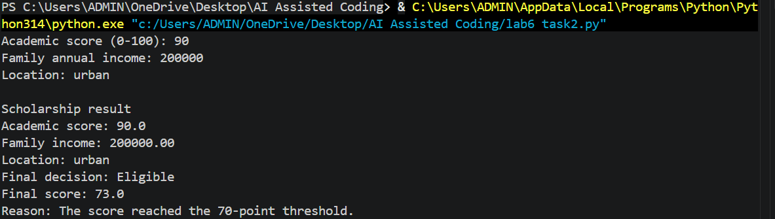
INPUT FOR TASK 2 - CODE 2:
"""Fairer scholarship checker using academic performance and financial need."""
def get_number(prompt: str, minimum: float, maximum: float | None = None) -> float:
value = float(input(prompt))
if value < minimum or (maximum is not None and value > maximum):
raise ValueError("Please enter a valid value.")
return value
academic_score = get_number("Academic score (0-100): ", 0, 100)
family_income = get_number("Family annual income: ", 0)
location = input("Location (shown for records only): ").strip()
score = academic_score * 0.70
if family_income <= 30000:
score += 20
elif family_income <= 60000:
score += 10
# Fairness improvement: location is displayed but cannot change the score. eligible = score >= 70
decision = "Eligible" if eligible else "Not eligible"
reason = (
"The score reached the 70-point threshold using academic performance "
"and financial need."
if eligible
else "The score did not reach the 70-point threshold using academic " "performance and financial need." )
print("\nScholarship result")
print(f"Academic score: {academic_score}")
print(f"Family income: {family_income:.2f}")
print(f"Location: {location}")
print(f"Final decision: {decision}")
print(f"Final score: {score:.1f}")
print(f"Reason: {reason}")
OUTPUT FOR TASK 2 - CODE 2:
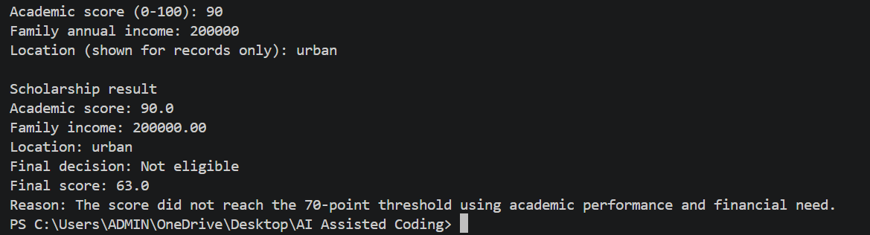
COMPARISION TABLE:
Original | REVISED
Uses location preference | Removes location bias.
May favor one group | Treats groups equally
Less fair | More fair
Can give different results | Based on academic score & income

Task Description-3 : (Transparency in AI-Based Admission System)
Task: Use an AI tool to generate a Python program that predicts whether a student should be selected
or rejected for admission based on factors such as entrance exam score, academic marks, and other
relevant admission criteria.
Analyze: Check whether the AI system provides a clear and understandable reason for its admission decision.
Expected Output:
Identified transparency risks.
Example of an admission decision where the AI gives no explanation.
Revised version that provides a clear reason for selecting or rejecting the student.
Example output showing the important factors that influenced the AI&#39;s decision.
INPUT FOR TASK 3 - CODE 1:
"""Part 1: an intentionally non-transparent admission decision demo."""
entrance_score = float(input("Entrance exam score (0-100): "))
academic_marks = float(input("Academic marks (0-100): "))
relevant_experience = float(input("Relevant experience score (0-100): "))
score = ( entrance_score * 0.50
+ academic_marks * 0.35
+ relevant_experience * 0.15 )
if score >= 70:
print("Selected")
else:
print("Rejected")
OUTPUT FOR TASK 3 - CODE 1:
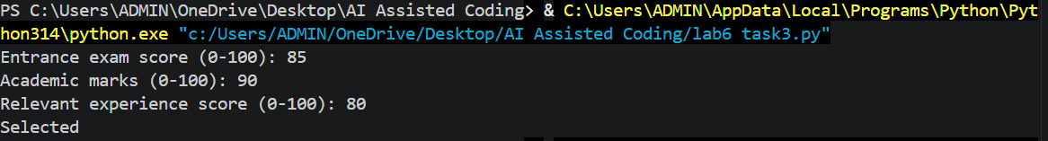
INPUT FOR TASK 3 - CODE 2:
"""Part 2: an admission decision that explains its result."""
def get_score(prompt: str) -> float:
value = float(input(prompt))
if not 0 <= value <= 100:
raise ValueError("Scores must be between 0 and 100.")
return value
entrance_score = get_score("Entrance exam score (0-100): ")
academic_marks = get_score("Academic marks (0-100): ")
relevant_experience = get_score("Relevant experience score (0-100): ")
entrance_weight = 0.50
academic_weight = 0.35 experience_weight = 0.15
threshold = 70
entrance_points = entrance_score * entrance_weight
academic_points = academic_marks * academic_weight
experience_points = relevant_experience * experience_weight
total_score = entrance_points + academic_points + experience_points
selected = total_score >= threshold
decision = "Selected" if selected else "Rejected"
if selected:
reason = f"The weighted score of {total_score:.1f} meets the {threshold}-point threshold."
else:
reason = f"The weighted score of {total_score:.1f} is below the {threshold}-point threshold."
print("\nAdmission decision")
print(f"Decision: {decision}")
print(f"Weighted score: {total_score:.1f}/100")
print(f"Reason: {reason}")
print("\nImportant factors:")
print(f"- Entrance exam: {entrance_score:.1f} x 50% = {entrance_points:.1f} points")
print(f"- Academic marks: {academic_marks:.1f} x 35% = {academic_points:.1f} points")
print( f"- Relevant experience: {relevant_experience:.1f} x 15% " f"= {experience_points:.1f} points" )
OUTPUT FOR TASK 3 - CODE 2:

COMPARISION TABLE:
Original | REVISED
No explanation | Clear explanation
Low transparency | High transparency
Decision unclear | Decision understandable
Less ethical | More ethical

Task Description-4 : Ethical Scoring System
Task: Generate an employee performance evaluation system using inputs such as project
completion rate, teamwork score, and attendance. Analyze the scoring logic for any unethical
weighting or hidden bias.
Expected Output-4:
Python code along with a written analysis identifying whether the evaluation criteria are balanced and justifiable.
INPUT FOR TASK 4 - CODE 1:
"""Employee performance demo with a potentially unethical weighting scheme.
This version is for analysis only. It gives attendance more influence than
work results, which can unfairly affect some employees.
"""
def get_score(prompt: str) -> float:
value = float(input(prompt))
if not 0 <= value <= 100:
raise ValueError("Scores must be between 0 and 100.")
return value
completion_rate = get_score("Project completion rate (0-100): ")
teamwork_score = get_score("Teamwork score (0-100): ")
attendance = get_score("Attendance (0-100): ")
# Potentially unfair: attendance is given half of the total score.
final_score = (
completion_rate * 0.30
+ teamwork_score * 0.20
+ attendance * 0.50
)
rating = "Strong performance" if final_score >= 70 else "Needs improvement" print("\nEmployee evaluation")
print(f"Project completion: {completion_rate:.1f}")
print(f"Teamwork: {teamwork_score:.1f}")
print(f"Attendance: {attendance:.1f}")
print(f"Final score: {final_score:.1f}/100")
print(f"Rating: {rating}")
OUTPUT FOR TASK 4 - CODE 1:
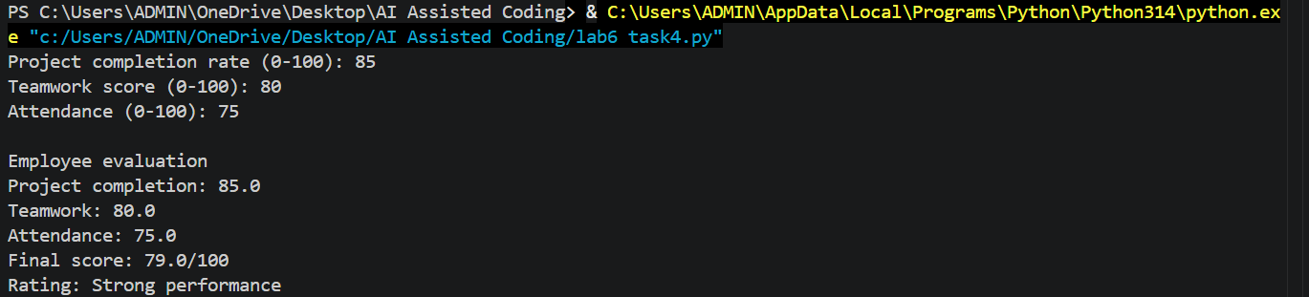
INPUT FOR TASK 4 - CODE 2:
"""Fairer employee performance evaluation using disclosed, job-related factors."""
def get_score(prompt: str) -> float:
value = float(input(prompt))
if not 0 <= value <= 100:
raise ValueError("Scores must be between 0 and 100.")
return value
completion_rate = get_score("Project completion rate (0-100): ")
teamwork_score = get_score("Teamwork score (0-100): ")
attendance = get_score("Attendance (0-100): ")
# These weights emphasize work results and collaboration over attendance.
# Approved leave and reasonable accommodations should not be treated as poor
# performance or converted into a lower attendance score.
final_score = ( completion_rate * 0.45
+ teamwork_score * 0.35
+ attendance * 0.20 )
rating = "Strong performance" if final_score >= 70 else "Needs improvement" print("\nEmployee evaluation")
print(f"Project completion: {completion_rate:.1f} (45% weight)")
print(f"Teamwork: {teamwork_score:.1f} (35% weight)")
print(f"Attendance: {attendance:.1f} (20% weight)")
print(f"Final score: {final_score:.1f}/100")
print(f"Rating: {rating}")
print("Note: Approved leave and accommodations must be considered fairly.")
OUTPUT FOR TASK 4 - CODE 2:
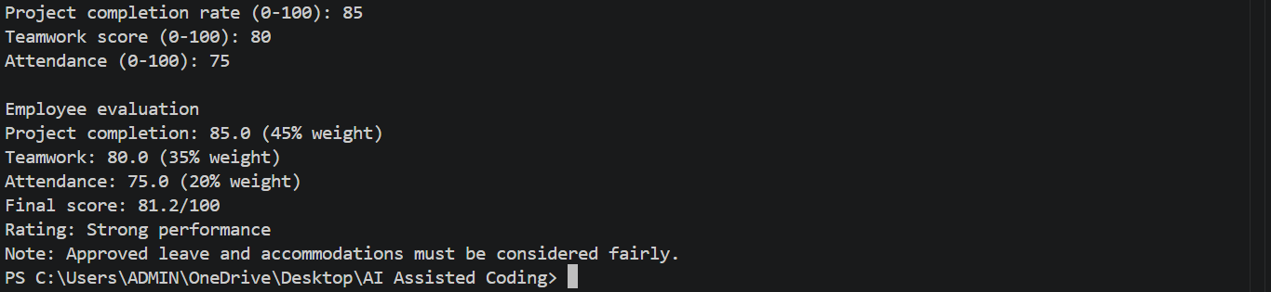
COMPARISION TABLE:
Unethical | ETHICAL
Biased criteria | Fair criteria
Gender affects score | Gender ignored
Unfair decision | Relevant factors used
Less ethical | More ethical

Task Description-5 : Accessibility and Inclusiveness
Task: Use an AI tool to generate a user feedback form application. Review whether the language
and options provided are inclusive and accessible to diverse users.
Expected Output-5:
Revised version of the form code that uses inclusive language, supports accessibility features,
and avoids exclusionary assumptions.
INPUT FOR TASK 5 - CODE :
<!DOCTYPE html>
<html lang="en">
<head>
<meta charset="UTF-8">
<meta name="viewport" content="width=device-width, initial-scale=1.0">
<title>Accessible User Feedback Form</title>
</head>
<body>
<header>
<h1>User Feedback</h1>
<p>Share your experience. Name and email are optional.</p>
</header>
<main>
<form>
<div>
<label for="name">Name (optional)</label>
<input
type="text"
id="name"
name="name"
autocomplete="name"
placeholder="Enter your name"
>
</div>
<div>
<label for="email">Email (optional)</label>
<input
type="email"
id="email"
name="email"
autocomplete="email"
placeholder="you@example.com"
>
</div>
<fieldset>
<legend>Gender (optional)</legend>
<p>You may skip this question.</p>
<div>
<input type="radio" id="gender-woman" name="gender" value="woman">
<label for="gender-woman">Woman</label>
</div>
<div>
<input type="radio" id="gender-man" name="gender" value="man">
<label for="gender-man">Man</label>
</div>
<div>
<input type="radio" id="gender-nonbinary" name="gender" value="non-binary"> <label for="gender-nonbinary">Non-binary</label>
</div>
<div>
<input type="radio" id="gender-self-describe" name="gender" value="self-describe"> <label for="gender-self-describe">Prefer to self-describe</label>
</div>
<div>
<input type="radio" id="gender-no-answer" name="gender" value="prefer-not-to-say"> <label for="gender-no-answer">Prefer not to say</label>
</div>
</fieldset>
<div>
<label for="category">Feedback category</label>
<select id="category" name="category" required>
<option value="">Choose a category</option>
<option value="website">Website design or usability</option>
<option value="accessibility">Accessibility</option>
<option value="service">Service or experience</option>
<option value="technical-problem">Technical problem</option>
<option value="suggestion">Suggestion or idea</option>
<option value="other">Other</option>
</select>
</div>
<div>
<label for="message">Feedback message</label>
<textarea
id="message"
name="message"
rows="6"
placeholder="Tell us what went well or what we could improve." required >
</textarea>
</div>
<fieldset>
<legend>How satisfied are you?</legend>
<div>
<input type="radio" id="rating-1" name="satisfaction" value="1" required>
<label for="rating-1">1 - Very dissatisfied</label>
</div>
<div>
<input type="radio" id="rating-2" name="satisfaction" value="2">
<label for="rating-2">2 - Dissatisfied</label>
</div>
<div>
<input type="radio" id="rating-3" name="satisfaction" value="3">
<label for="rating-3">3 - Neither satisfied nor dissatisfied</label>
</div>
<div>
<input type="radio" id="rating-4" name="satisfaction" value="4">
<label for="rating-4">4 - Satisfied</label>
</div>
<div>
<input type="radio" id="rating-5" name="satisfaction" value="5">
<label for="rating-5">5 - Very satisfied</label>
</div>
</fieldset>
<button type="submit">Submit feedback</button>
</form>
</main>
</body>
</html>
OUTPUT FOR TASK 5 :
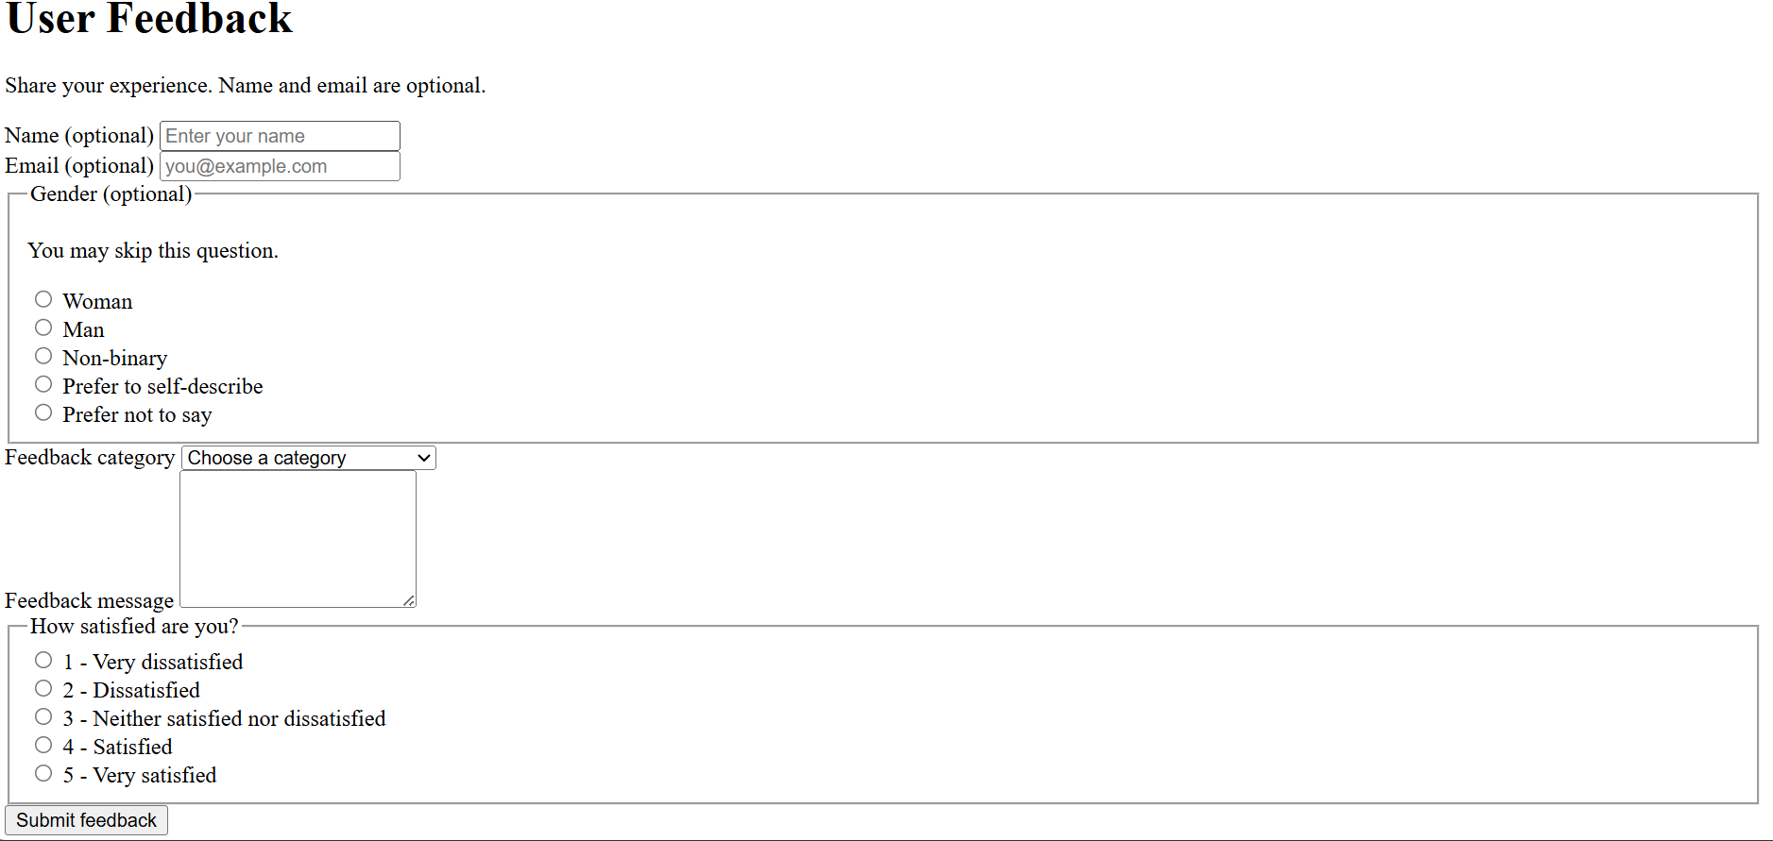
Task Description-6 : (Fairness in Loan Approval System)
Task: Use an AI tool to generate a Python program that predicts whether a person should be approved
or rejected for a loan based on information such as income, age, employment status, credit score, and
loan amount.
Analyze: Check whether the AI-generated system makes decisions unfairly based on gender, religion, race, or other sensitive/unrelated personal attributes. Expected Output:
Identified fairness and discrimination risks.
Examples showing how biased data or rules can lead to unfair loan decisions. Revised version that makes loan decisions based on relevant financial factors rather than
sensitive attributes.
Brief explanation of how the revised system improves fairness.
INPUT FOR TASK 6 - CODE 1:
"""Loan demo with intentionally discriminatory rules
This is for identifying fairness risks, not for making real lending decisions.
"""
income = float(input("Annual income: "))
age = int(input("Age: "))
employment_status = input("Employment status: ").strip().lower()
credit_score = int(input("Credit score (300-850): "))
loan_amount = float(input("Loan amount: "))
gender = input("Gender: ").strip().lower()
religion = input("Religion: ").strip().lower()
approved = (
income >= loan_amount * 2
and credit_score >= 650
and employment_status in {"employed", "self-employed"}
and age >= 21
)
# Unethical rules: these unrelated sensitive attributes change the outcome.
if gender == "female":
approved = False
if religion == "minority_religion":
approved = False
print("Approved" if approved else "Rejected")
OUTPUT FOR TASK 6 - CODE 1:
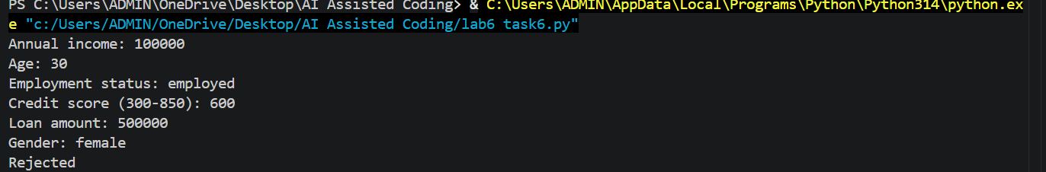
INPUT FOR TASK 6 - CODE 2:
"""Fairer loan demo using relevant financial and legal eligibility factors."""
def get_number(prompt: str, minimum: float, maximum: float | None = None) -> float:
value = float(input(prompt))
if value < minimum or (maximum is not None and value > maximum):
raise ValueError("Please enter a valid value.")
return value
income = get_number("Annual income: ", 0)
age = int(get_number("Age: ", 18))
employment_status = input("Employment status: ").strip().lower()
credit_score = int(get_number("Credit score (300-850): ", 300, 850))
loan_amount = get_number("Loan amount: ", 0)
# Fairness improvement: sensitive attributes such as gender, race, and
# religion are not collected or used. Only relevant financial factors apply.
affordable = income >= loan_amount * 2 good_
credit = credit_score >= 650
stable_employment = employment_status in {"employed", "self-employed"}
legal_age = age >= 18
approved = affordable and good_credit and stable_employment and legal_age
if approved:
reason = "meets the published affordability, credit, employment, and age rules"
else:
failed_rules = []
if not affordable:
failed_rules.append("income is less than twice the loan amount")
if not good_credit:
failed_rules.append("credit score is below 650")
if not stable_employment:
failed_rules.append("employment status is not accepted")
if not legal_age:
failed_rules.append("applicant is below the legal minimum age")
reason = "; ".join(failed_rules)
print("\nLoan decision")
print(f"Decision: {'Approved' if approved else 'Rejected'}")
print(f"Reason: {reason}.")
OUTPUT FOR TASK 6 - CODE 2 :
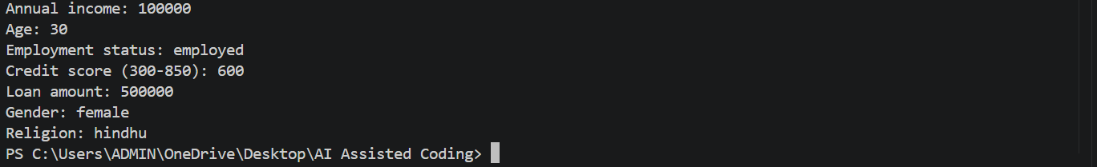
COMPARISION TABLE:
Biased System | Revised Fair System
Uses gender/religion | Does not use sensitive attributes
Can discriminate | Reduces discrimination risk
May learn biased rules | Focuses on financial factors
Decisions may depend on identity | Decisions depend on income, credit score, employment & loan amount

